RESOLUTION NO.__________

RE: CERTIFICATE OF APPROPRIATENESS UNDER THE
PROVISIONS OF THE ACT OF THE PENNSYLVANIA
LEGISLATURE 1961, JUNE 13, P.L. 282 (53
SECTION 8004) AND BETHLEHEM ORDINANCE NO.
3952 AS AMENDED.

WHEREAS, it is proposed to install a sign above the entrance, replace an existing hanging sign, place lettering above the left display window and install vinyl lettering on the door at 550 Main St. (The Gem Shop)

NOW, THEREFORE, BE IT RESOLVED by the Council of the City of Bethlehem that a Certificate of Appropriateness is hereby granted for the proposal.

Sponsored by: (s)

(s)

ADOPTED BY COUNCIL THIS DAY OF

(s)
President of Council

ATTEST:

(s)
City Clerk

HISTORICAL & ARCHITECTURAL REVIEW BOARD

The applicant proposes to install a sign above the entrance, replace an existing hanging sign, place lettering above the left display window and install vinyl lettering on the door at 550 Main St. (The Gem Shop)
APPLICATION #1:

Danis Botrus/Danielle Mulligan
1805 Vintage Drive
Easton, PA 18045

OWNER:

__________________________________________________________________

The Board upon motion by Gen Marcon and seconded by Marsha Fritz adopted the proposal that City Council issue a Certificate of Appropriateness for the following:

- Install a gold metal sign above the left display window and letters to be mounted
to the aluminum window frame.

2. Vinyl letters to be placed on the door showing the business name and hours of
operation.

3. Sign above the canopy is to be eliminated.

4. Install an oval hanging sign under the canopy.

5. The motion was unanimously approved.

__________________________________________________________________________

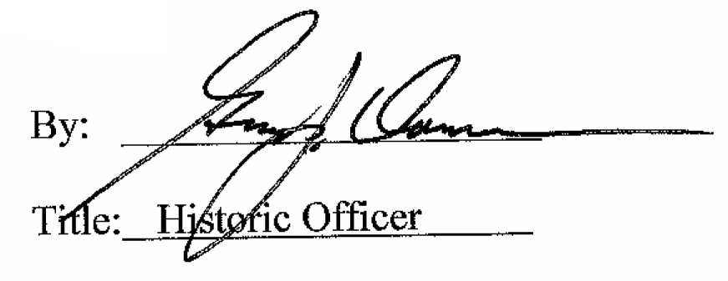

Date of Meeting: June 1, 2016

